1. **INTRODUCTION**
   1. **OVERVIEW**

Electricity consumption is an essential component of the modern life. It not only provides clean and safe light throughout the day, but also in many countries refreshes homes on hot summer days, and in others warms them in winter. In all countries, it allows the use of electrical and electronic equipment in which the use of electricity is essential to ensure their proper functioning. Electricity consumption has continued to go up rapidly at a rate faster than energy consumption.

Since the twenty first century, global electricity consumption has seen even faster growth, as evidenced by an average annual increase of 3.4%, 1.2 percentage points higher than average annual growth of energy consumption.

* 1. **PURPOSE**

People use electricity for lighting, heating, cooling, and refrigeration and for operating appliances, computers, electronics, machinery, and public transportation systems.

The proportion of electricity consumption for primary and secondary industry in the eastern region is significantly lower than the national average. Also, the proportion occupied by tertiary industry is higher than the national average. The proportion of residential electricity consumption is close to the national average.

1. Problem Definition & Design Thinking
   1. Empathy Map

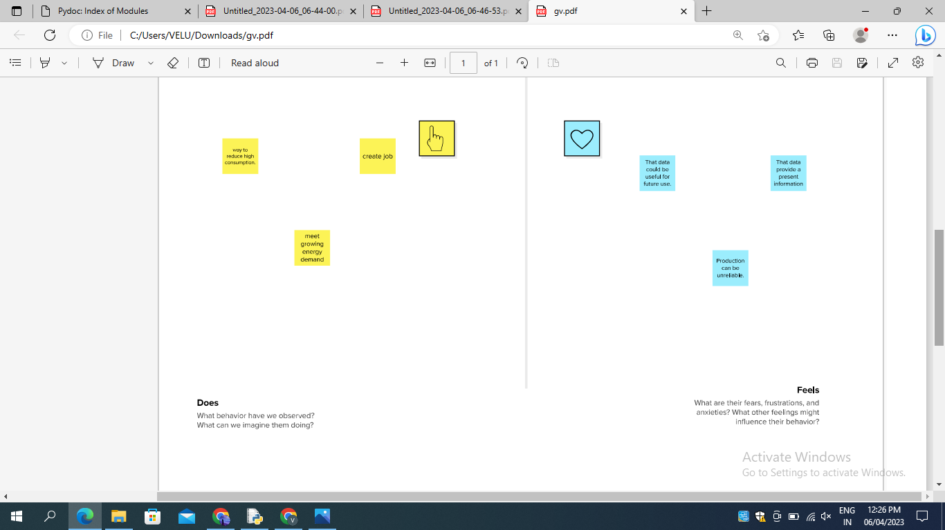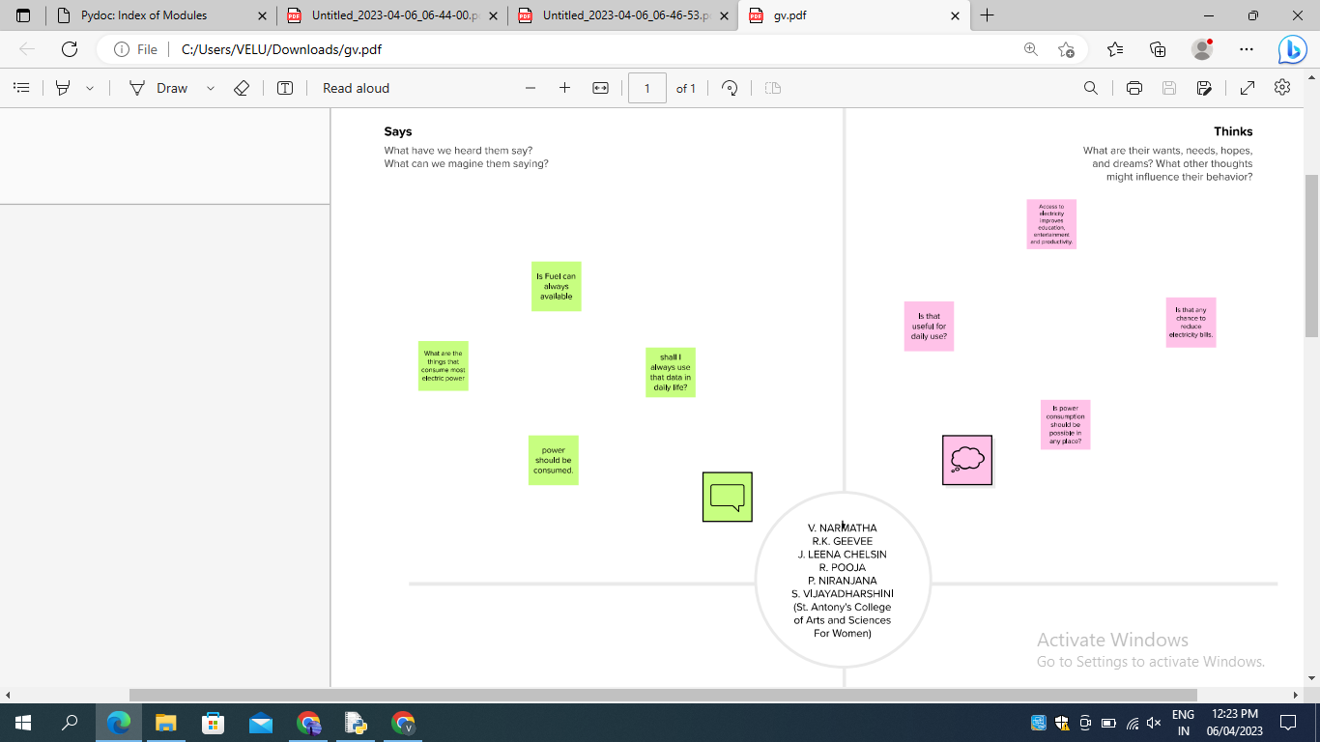

2.2 Ideation & Brainstorming Map

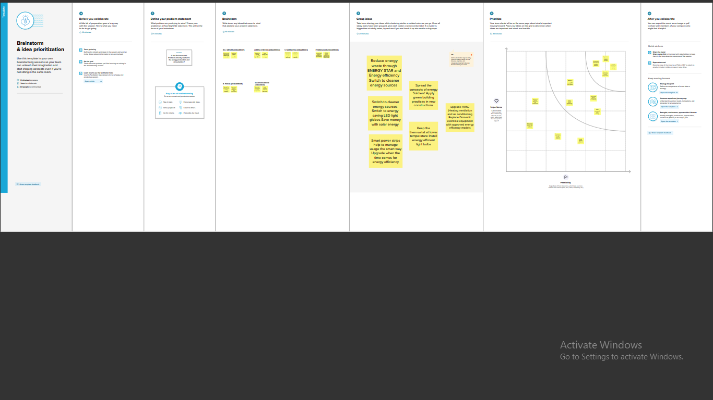

1. **RESULT**

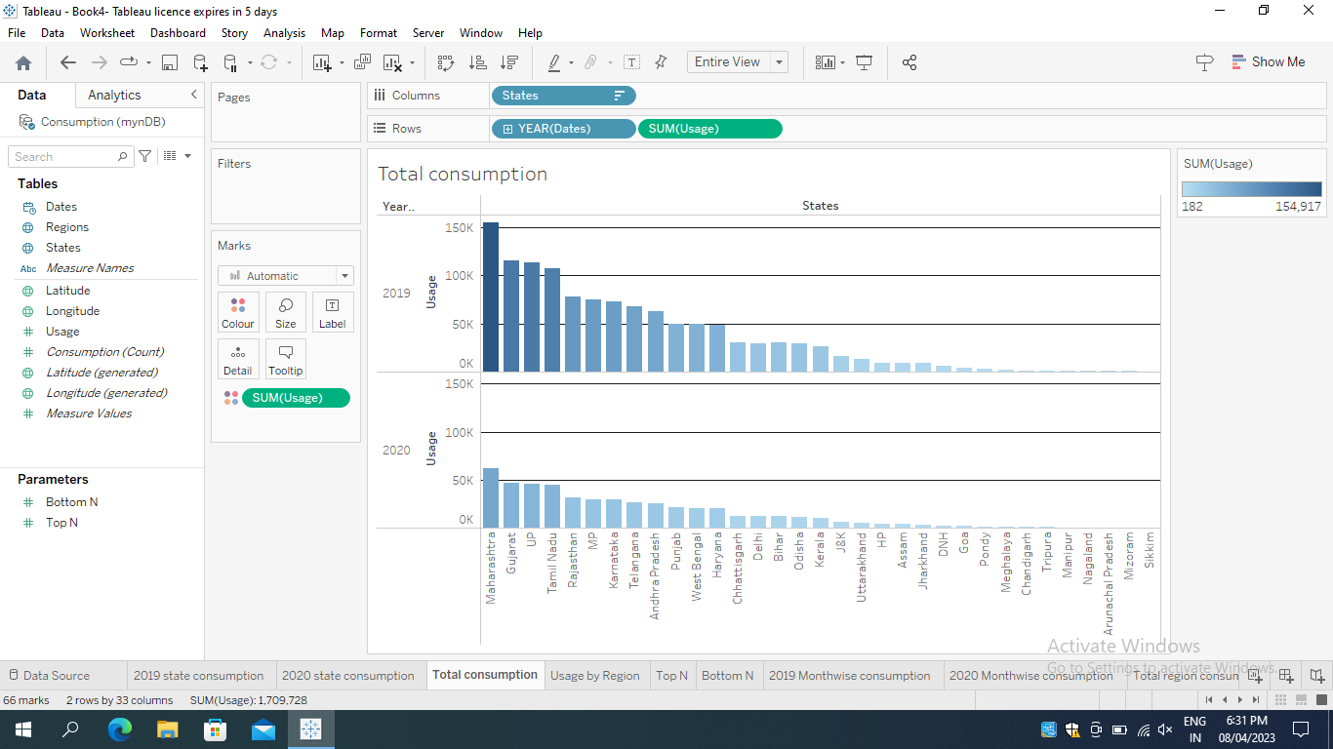

1. Maharashtra is the highest electricity consumer state in India.
2. Gujarat is the second highest electricity consumer in India.
3. Sikkim is the least electricity consumer in India.
4. **ADVANTAGES**
5. More efficient.
6. It is renewable.
7. Hydro electricity produces no gas emission.
8. From this project we easily understand consumption pattern.
9. So we have the knowledge to understand and make the beneficiary use of it.

**DISADVANTAGES**

1. Drought can affect power production.

1. Power plants that burn biomass release sulphur dioxide and nitrogen oxides, two undesirable pollutants into the air.
2. Power plants that burn fossil fuel CO2 into atmosphere.
3. CO2 is a greenhouse gas that causes Earth’s temperature to rise.
4. **APPLICATIONS**
5. For industrial sector the electricity consumption pattern is very useful to know in which particular time they had more usage.
6. It also plays a vital role in economical sector.
7. Annual electricity consumption per capita serves us an important measure of a country’s electric power development.
8. Generally speaking electricity consumption grows faster when the industrialization process develops quickly and goes down rapidly when industrialization is completed or near completion.
9. The industrial sector uses electricity for operating industrial motor and machinery, lights, computers and office equipment.
10. **CONCLUSION**

The aim of this project was to identify the variables that influence the generation, the consumption and the usage of the electricity in India

.We have seen that the generation of electricity in Indian states is driven by the number of commercial and industrial customers. Concerning the electricity consumption, it is influenced by the energy production itself and the amount of commercial customers. Our prediction models are quite accurate and confirmed the results of our exploratory data analysis. About our models, we should not forget that lots of variables can explain the electricity consumption and production as we have seen during the exploratory data analysis, but we only used the most significant ones.

Energy efficiency is the wave of the future. The world is quickly moving towards energy sustainability. At the same time, the mankind is trying to re-establish the connection it once had with nature. An energy efficient home is a personal step toward the direction of renewable energy, environmental protection, and sustainable living. Having such a home helps homeowners reduce their bills and provides an excellent investment. Furthermore, energy efficiency means healthier and more comfortable living that is in line with nature.

From our findings we can conclude that,

1. Maharashtra is the highest electricity consumer state in India.
2. Gujarat is the second highest electricity consumer state in India.
3. Sikkim is the least electricity consumer state in India.
4. FUTURE SCOPE

The Indian power sector is forecasted to attract investments worth $128.24-135.37 Bn between FY19-23. The future of the sector looks bright since by 2026-27 the country's power generation installed capacity will close to 620 GW, of which 38 % will be from coal and 44% from renewable energy sources.

As the Indian government plans to increase electrification of rail-route kilometres from 40 percent presently to 77 percent by 2022, the level of electricity consumption achieved by 2030 could be 35-43 TWh, growing at 5.0-6.3 percent CAGR from 17 TWh in 2015.

The ever-expanding industrialization and urbanization will primarily drive the energy demand that is forecasted to reach 405 Gigawatts of renewable energy capacity by 2030.